PAYMENT GATEWAY - SPECIFICATION DOCUMENT

API Generic

Version 1.7

19 May 2023

Document Owner: Belewete, Christian, Vodacom DRC

Version History

*-* 17-Aug-22
*-* 15-Oct-22 "‘ 24-Oct-22
7-Nov-22

i.s 10-Nov-22
13-Mar-23 '-^ 13-Mar-23
'-° 13-Mar-23
Christian Belewete Christian Belewete Christian Belewete Christian Belewete

Christian Belewete Christian Belewete Christian Belewete Christian Belewete
Initial draft
Adding flows, connection details, samples Update asynchronous flow
Update APIs : CreateTill, QueryCustomerKYC, QueryOrganizationKYC, QueryCustomerTransactions, SearchTransactions
Update Asynchronous flows Update Asynchronous flows Update Overdraft flows Update Overdraft flows

Vodacom Proprietary and Confidential. Rev4
Copyright O 2023. Vodacom Congo S.A

Vodacom Proprietary and Confidential. Rev4
Copyright 2023. Vodacom Congo 5.A

vodocom
BMIling & IT — Mobile Money and VAT

Contcn ts
2f!'MiOn Hi5tO/. 1
2 fOnnf!'CñOH df!'tailS 6
APIFIovv. 7
- \ \FIChFOFJOUS FPqME'5t. 7
  - AS\FJChFOEtOU5FE'QUE'5t. 7
4 A I BMI S |g B FB FD€'U FS 8
4 1 Lo8in.--'. 8
- 1. R€'C| u E'St @ B FB FD€'U FS. 8
    - R£!S OnSE'9SFdVPtE'F5. 8
  - 5\nC M£!F\ 9
  - R€'C| u E'St @ B FB FD€'U FS. 9
    - R£!S OnSE'9SFdVPtE'F5. 10
  - A }FICQtJ£'F\ 10
  - \ R£'qtJE'5t @BFBFD£'tE'F5. 10
    - R£!S OnSE'9SFdVPtE'F5. 10
    - R£!Su4t 9SFdVPtf!'FS. 11
  - 5p£!CiÉCDdtd DiCÉOnSF\ 11
    - Default. 11
    - QueçBaIance(CVM) 11
  - AuditDicfionary. 11
S APlCallsSamples. 12
h.\ LO8iEtSdFD|0lE'1 t \FJChFOFlOU5]. 12
  - LO8i| SdVplE'2 j5\nChFOHOU5j. 12
  - CVM Query Balance sample 1 (Synchronous] Error! Bookmark not defined.
  - CVM QueryBala nce Sample 2 (Synchronous] Error! Bookmark not defined.
  - QueryB alance Sample 1 (Synchronous) Error! Bookmark not defined.
  - Pay8il I — Normal Sa mple (Asynchronous) Error! Bookmark not defined.
  - Pay8il I — BuyBunde Sa mple (Asynchronous) Error! Bookmark not defined.
  - QueryC ustomerTrans act on (Synch ronous] Error! Bookmark not defined.
  - Create Till (Synchronous] Error! Bookmark not defined.
  - QueryCustomer KYC (Synchronous) 12
  - Queryorganizal onKDC (Synchronous]. 13
  - SearchTransacfion (Synchronous) Error! Bookmark not defined.
  - B2C with KYC validafion (Asynchronous) Error! Bookmark not defined.
  - Overdraft Repayment (Synchronous) Error! Bookmark not defined.
Voda«ori Pr uorieta ry a nd Confides £ial. Rev4
Copyright 2023. Vodacom Congo S.A
*a8e 3if 16

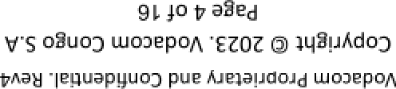

aauaJajay JoJJ$ g

çp/\ pue Xauo amigos — /¡ g BU!II!8

1NZI/\IFI3OO NOl1YDlJl33d5 - AV/¥\Z1V3 1N3I/\IXVd
wooopow


vodocom

- Pre-requisites

Billing & IT — Mobile Money and VAS

Below items are required before for System Owner of Payment Gateway to proceed with Third-Party onboarding

7 Ensure end ro end connecr!vity
Third-Party Identification details Username
Password
VDRC/ Network fieam/ Tt›ird Party
Payment fiafieway Uwner

Vodacom Proprietary and Confidential. Rev4
Copyright @ 2023. Vodacom Congo S.A Page 5 of 16

vodocom

Conn uctiuii tlctails



BMIling & IT — Mobile Money and VAT

https://Hatipg.m -pesa.vodacom.cd:9090/oauth/v1 https://uati pg.m-pesa.vodacom.cd:9091/api/v1 https.//uati pg.m-pesa.vodacom cd.9092/api/v 1 192 168 115 5 7
41.78.195.169





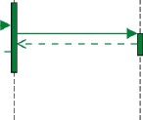

https.//ipg. m-pesa.Vodacom cd.9090/oauth/v1 https://i pg.m-pesa.vodacom.cd:9091/api/v1 https://i pg.m-pesa.vodacom. cd:909 2/api/vL igz.i68.115.245
41.7B. 195.1B3
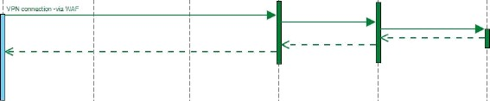
10.90.4.100 10.90.104.100

Voda«ori Pr uprieta ry a nd Confides £ial. Rev4
Copyright 2023. Vodacom Congo S.A
^a8E' 6 of 16

vodocom

- AP!F1ow

Synchronous request

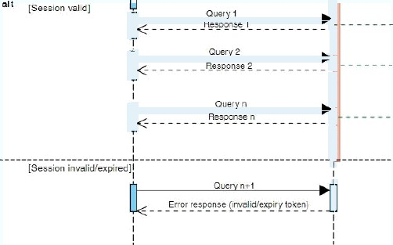

G ustomei
Leg in request

Asynchronous request
Billing & IT — Mobile Money and VAS

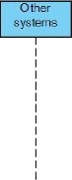
In rnal queries c'
•0 wm



” ther'eys1e'ms



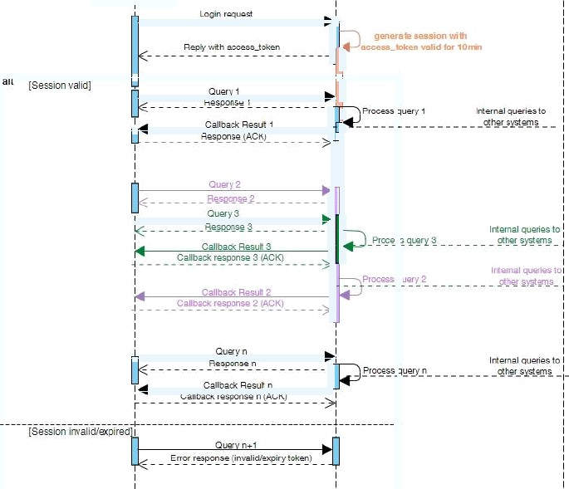
vodocom


Cusomer

API Calls pai aineters

1.1 Login
PAYMENT GATEWAY - SPECIFICATION DOCUMENT

API frenetic

Billing & IT — Mobile Money and VAS

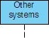
F'ayment ua


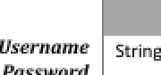
M 64 Third pa rty's username
64 ThrdpadyspaawoM
User I


PAYMENT GATEWAY - SPECIFICATION DOCUMENT
API Generic

vodocom

access. Tahn String

Billing & IT — Mobile Money and VAS

M unlimited Return the JWT token if success or the ewoglCJhbEziOiAiSFMyNTYiLAogTCJ0eXAiOiAi5Td UIgp9

failure reaso n in case of fail ure

.ewoglCTpc3M iOiJpcGct YWEubs LwON h LnZvZGFj b20u Y2Qi LAogICTzdWI iO iTZ NWJ iND\/mYTBiMTk0ODM0O DTj Mj IwYz M wM DYE M WIIM 5IsCiAgTmF1ZCI6I kEgdGvzdCB B U EkgR2F0Z XdheSlsCiAgl mV•zCT6IjI wMj It M Dg£MTcg

MNja M
D M$
U fQ==.769 L2e*Ba'
%MjA M N

String 0
String 0

String 0

String M

i6 Represen re th e type of th e roken
32 Represen re th e time when token was

32 Represen rs th e Lime when token wil I expire
32 Represen rs th e code of the transaztío n
0baI9#33#e#lB0fddr87 rea4;#f3Ic£2Z6e
Bearer
2D220%i;i6d0.IN

2D220Si;i6J0.I£

0 for success logon
-J for la iled logon



M 2 0'tB Represents rhe access token received fro m login
caT|

e ogICJhbGciOiAi5FMyNTYiLAog ICJ0e
xAioi isidulzps. gic pr3MioiJp<s
ctY\N’E u b5 Lw ZXNhLnZvZG Fjb2Du Y2QiL Aogl cJzdWl iOi I3 NWJi NDVrnYTBi MTk0 ODMOODI jM j IwYz M wM DYzMWI LMSI
sCiAgl m F1ZC 161 kEgdGVzdCBBUE kgR2F 0ZXd he5I sCń4g ImV'Tc€ I6Ij Iw Mj ItM Dgt
MTcgMTY 6M jA6M j UiLAoglCJp WQ iO i

,fMMt;2e,:,H,.dNji‘MDed,bf.

M
Mtnestomp 5trir\g M
TdeftT/Ues List < Iderrfity > O
32 Third part reference
L• Third part's Timestamp
£2 34S6789a hcesrdsf7 I
i.e . 2022n zzosi709

6onaocUon Dic£<Trans.act\onData› M


Idenfity parameters
M
M
Ident\fier Type
M SISDN. 5hor£‹ode ID
M L2 Tdent\fier value 24 38 LJ LJ J LJ J

Transa‹t\onData d ict onary
M
32
Represents rhe funcfion called
List <Re erenceDateTtem> 0 List of references associated to the era nsacLion

Referen‹eData Parameters

Vodacom Proprietary and Confidential. Rev4


vodocom
PAYMENT GATEWAY - SPÉCIFICATION DOCUMENT

API €ierreiie

Billing & IT — Mobile Money and VAS



M
M 0

D ict < 5pecifi‹Data > M
Code of the result Descripfion of th e resul £
32 Represents third party ID
32 Represents i PG ID
Represents specific resu It values of the function requested. May vary from a funcfion to an other
0
Process service reques£ sucresseul Iy L2 Z4567B9a bcescdsf2l
Tj ERpy NbFDZI F0Sc5 PPSE IM hsd PwxcmG
i.e . Ïor querybalance funcfion ils return balances of CDF and U5 D wz IIet.
Or nu IT if the request Ïa iled

  - ASync Qnei'y
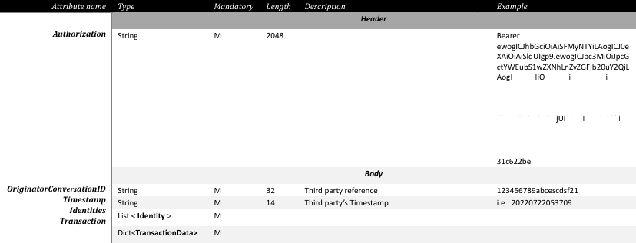
Represents rhe access token received fra m login
cJzdW iI3 NWJ NDVrnYTB MTk0
ODMOOD M EM
MdC UE' M2F
0ZXd he5I sCiAg im V4cCI6I jIw Mj ItM Dgt MTcgMTY 6M jA6M LAog CJpWQ iO'
K
94 3 9B dN B d 7 fz

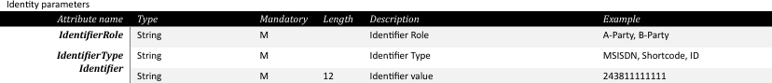

Transa‹tîonData d ictionary


Refeien‹eData Parameters
32 Represents the fu ncfion called
List of references associated to the era nsacfion
i.e . Quer yBaTance


O O
Z 2
Z 2
Represen fr th e name of the reference
Represen es th e val ue of th e referen œ
i.e . Call BackDestînafiori
i.e .

Vodacom Proprierary and Confidentïal. Rev4


vodocom

API €ierreiie

Billing & IT — Mobile Money and VAS

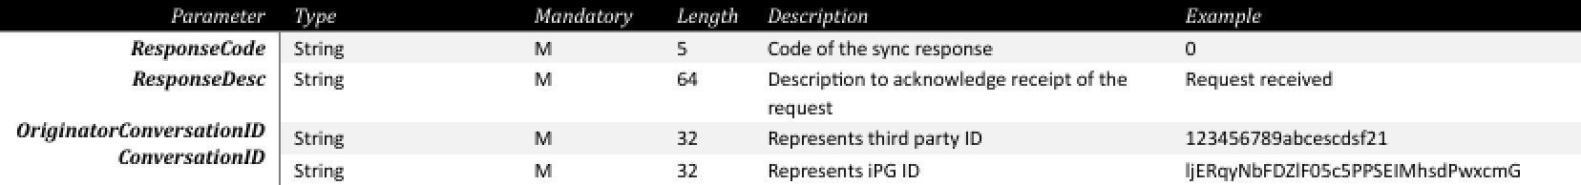
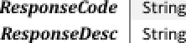

M

M
32
32
Code of the sync response
Descripfion to ask now ledge receipt of the req uest
Represents third party ID
Represents iPG ID
o
Req uest received
L2Z4567B9a bcescdsf2l
TjERpyNbFDZl F0Sc5 PPSE IM hsd PwxcmG


M
32

M 32
0
Code of the result Descripfion of th e resul £ Represents third party ID Represents iPG ID
Represents specific resu It values of the function requested. May vary from a funcfion to an other
0
Process service request successoul Iy L2 Z4567B9a bcescdsf2l
TjERpy NbFDZI F0Sc5 PPSE IM hsd PwxcmG
i.e . for querybalance funcfion its return balances of CDF and U5D wz IIet.
Or nu IT if the request la iled

oJ:idle D ict < 5pecifi‹Data > M

Syccif’icData Dictio r›ai y

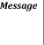
4.4.1 Dufiiult
O
Indicates success of a message indicating the
way O fix la iled transaefion Curren cy parameter reguired

4.4.2 Q iiurJ-Biiliinct' (CI’M)

0
0
0 Z 2
0 Z 2
Currency req uested

Represen Is G2 USD wallet available balance
Represen re G2 C D £ wal let avai IabTe balance
USD or CDF
i.e. 202 207 22DS3 J09
i.e. 10. 50
i.e : L2S0

Aunit Di coronary

sfor\J'/me Datefime
completed' time Datefime
M 1•
M £4
Na me of th e rel'erence sent with the req uest Val ue of the reference
i.e.20Z20722oS3;09
ie.20I207220S3;09

originat. LIMe Datetime
M 1• Represents thfrd-party fimesta mp
i.e.20Z20722oS3;09

Vodacom Proprietary and Confidential. Rev4

API Calls Samples

Request
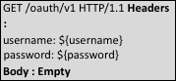

Response
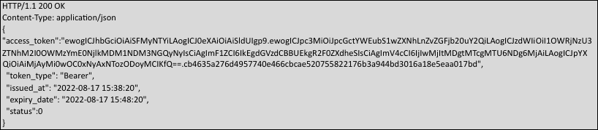

S.2 LogJin siiiii plc 2 ( Sy'nc11i otie us}

Request
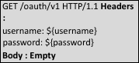

Response
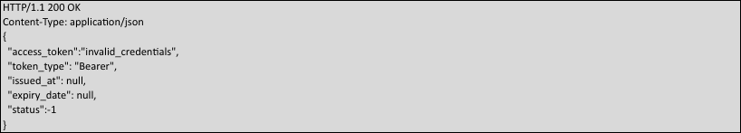

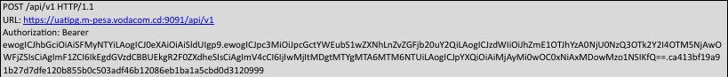
Request
Vodacom Proprietary and Confidential. Rev4

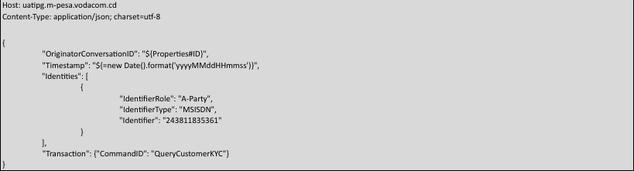

Response
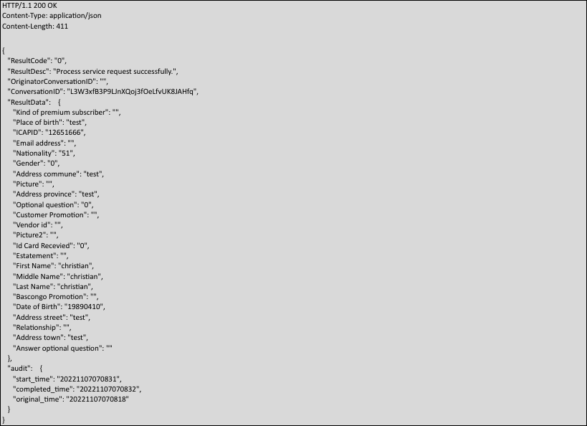

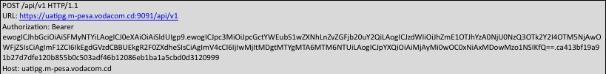
Request
Vodacom Proprietary and Confidential. Rev4

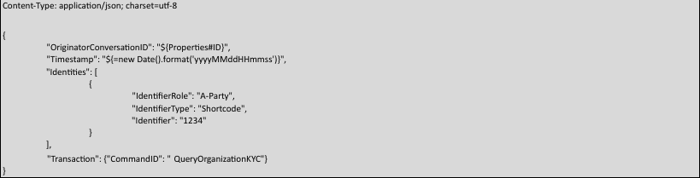

Response
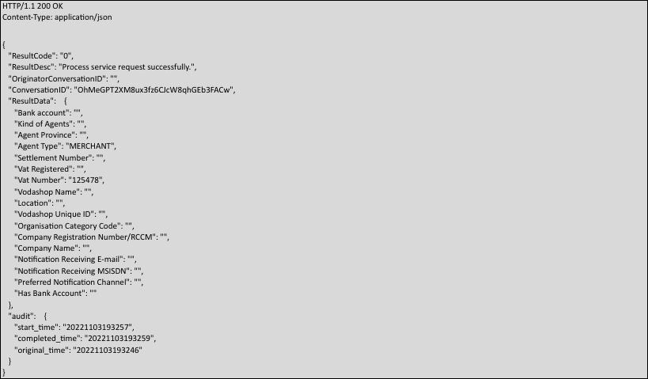

b Errvr Reference

0 Process service request Successfully
-J System internal error.
-* Some mandatory fields are missing
Invalid token
-s tic not validated
Customer did not validate confirmafion push Customer did not validate PIN push
-8 Customer cancelled the push
-9 Customer entered wrong oprion
Request Successful

Timeout or no response

Vodacom Proprietary and Confidential. Rev4

J000 System is busy, the service request Is rejected. Caller authent!cat!on error.

Caller incorrect credentials used

JOOZ JOOZ

20fi9

2JOJ

2JAS
2JIt7
Parameter missing or data type error Dupllcate orlginator coiwersation ID. Servlce code error
Initiator authenrlcarlon error.

Receiver invalid.
Currency liwalld.

Amount liwalld.

Rule limlted.
Balance insufficlent.
Conversation ID invalid.
Request has been rejected by the approver.
Request process explred because of approval rlmeout.
F1Ie load error.
One and only one of the query parameter RecelptNumber OrlginatorConversationlD and ConversationlD can appear at the same r!me.
MSISDN Invalid. kYC field invalid. Trust level 1nvaIld.
Account Type invalid.
New operator ID 1nvaIld.
New PIN liwalld. Language code invalid. Voucher invalid Product 1nvaIld.
Product mlsmatched.
ShonCode 1nvaIId or already used by another identity. TlllNumber liwalid or already used by another Idenrlty. OperatorlD invalld or already used by another identity. UserName liwalid or already used by another Idenrlty. OperatorRole invalid or not 1n available range.
The mandatory KYC is missing.
MSISDN should be absent when Recelver is a Till.
MSISDN Is Inconslstent wlth Recelver MSISDN.
ReglsterBy should be absent when inlt1ated by orgoperator. Products of Till cannot be all deleted.
Recelver should be absent when Initiated by Orgoperator
O2CLInk number InvaIId. Dupllcate O2CLInk number. Dupllcate TaxCode.
The Caller was Suspended by CustomerCare.
StartTime cannot be later then EndTlme.

Incorrect credentials used on

Currency allowed are USD/CDF
Integer for CDE Float with 2 decimals for USD

2M2

Z115
2M6
2M7
2M8

6JJJ
6M2
6M3
6M4
b11S

2802
Duplicate verification question.
Transaction status invalid.
Only transactions can be quelled by SearchTransaction. OrlginatorConversat1onlD or Conversat1onlD Invalid, the request does not exist. The request being queried cannot be a query operation.
Initiator cannot perform an operation on the self. The ldent1ty is not suspended by Customer Care. The Origlnal state cannot be changed to new state. The PIN 1s not locked.
The correspondlng point account does not exist.
The receiver 1s not supported for the operation. The loyalty point account balance Is Insufflclent. The identity account to be created already exlsts.
Mulrlple loyalty point accounts are matched based on then input parameter. Thls adjustment category 1s incorrect.
The amount format is incorrect.
The amount can not be 0.
Field length exceeds the maximum. Can not flnd the loyalty polnt account. No loyalty point account log is found. Incorrect lnput parameters.
The correspondlng PolntType Is not found in the system.
The correspondlng PolntType Is not In Released state.
The loyalty polnt account type found in the system is not appllcable to the current identity.
The date format 1s incorrect. Loyalty points fail to be queried. The amount can not be 0.
The idenrlty does not have any loyalty point account, Failed ro query the loyalty polncs.
Invalid Image S1ze Invalid File Type

